Traffic Sign Recognition Using Deep Learning
Abstract
Traffic signs play an important role in road safety by providing information and warnings to drivers. Manual recognition of traffic signs can be challenging in complex traffic environments. This project presents a Traffic Sign Recognition System using Deep Learning techniques. A Convolutional Neural Network (CNN) is trained to classify traffic sign images into 43 categories. The system automatically processes uploaded images and predicts the corresponding traffic sign, helping improve road safety and supporting intelligent transportation systems.
Introduction
Traffic Sign Recognition is a computer vision application that enables machines to identify and classify road signs from images. It is widely used in autonomous vehicles and driver assistance systems. The objective of this project is to develop a CNN-based model capable of accurately recognizing traffic signs from images.
Objectives
- To build a deep learning model for traffic sign classification.
- To classify traffic sign images into 43 categories.
- To automate traffic sign recognition using image processing techniques.
- To provide accurate predictions for uploaded traffic sign images.
Dataset
The project uses the German Traffic Sign Recognition Benchmark (GTSRB) dataset. The dataset contains thousands of labeled traffic sign images belonging to 43 different traffic sign classes.
Dataset Features
- 43 traffic sign categories
- Colored traffic sign images
- Multiple viewing angles and lighting conditions
- Real-world traffic sign samples
Methodology
Data Preprocessing
- Image resizing to 30×30 pixels
- Image normalization
- Dataset splitting into training and testing sets
Model Architecture
A Convolutional Neural Network (CNN) is used for image classification. The model consists of:
- Convolutional Layers
- Max Pooling Layers
- Flatten Layer
- Dense (Fully Connected) Layers
- Output Layer with 43 classes
Training Process
- Loss Function: Categorical Crossentropy
- Optimizer: Adam
- Framework: TensorFlow/Keras
- Training performed on the GTSRB dataset
System Workflow
- Load the trained CNN model.
- Upload a traffic sign image.
- Resize the image to the required dimensions.
- Feed the image into the trained model.
- Predict the traffic sign category.
- Display the image and prediction result.
Tools and Technologies
- Python
- TensorFlow
- Keras
- NumPy
- Pillow (PIL)
- Matplotlib
Results
The trained model successfully identifies traffic signs from uploaded images. The system can recognize various signs such as:
- Speed Limit Signs
- Stop Signs
- Road Work Signs
- Children Crossing Signs
- Traffic Signals
- No Entry Signs
The model demonstrates effective classification performance on unseen traffic sign images.
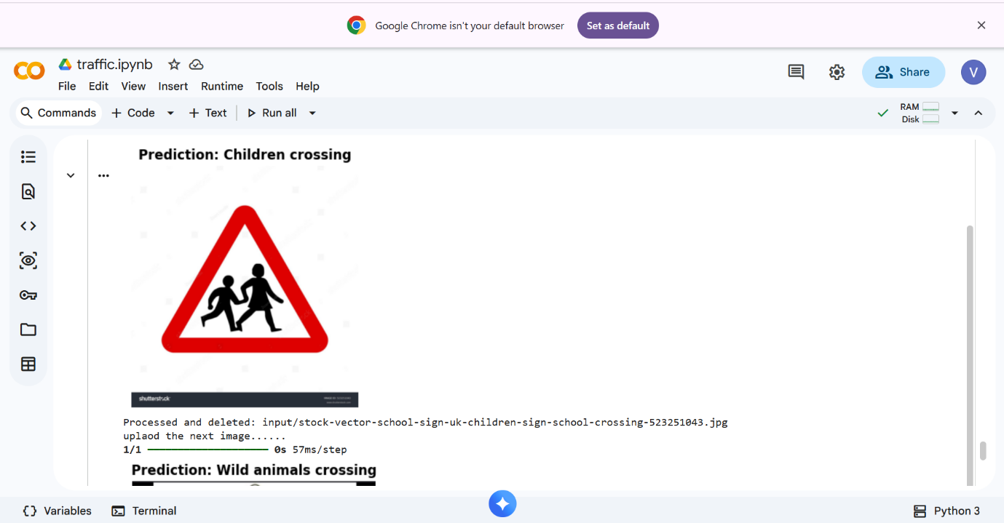
Applications
- Autonomous Vehicles
- Driver Assistance Systems
- Smart Traffic Management
- Road Safety Monitoring
- Intelligent Transportation Systems
Advantages
- Automatic traffic sign recognition
- Fast and accurate predictions
- Reduced human intervention
- Supports intelligent driving systems
Future Enhancements
- Real-time webcam detection
- Mobile application deployment
- Integration with autonomous vehicles
- Improved accuracy using advanced deep learning models
- Support for additional traffic sign datasets
Conclusion
This project successfully implements a Deep Learning-based Traffic Sign Recognition System using a Convolutional Neural Network. The model can accurately classify traffic signs into 43 categories and provides an efficient solution for intelligent transportation and road safety applications. The project demonstrates the effectiveness of deep learning techniques in solving real-world computer vision problems.
References
- German Traffic Sign Recognition Benchmark (GTSRB)
- TensorFlow Documentation
- Keras Documentation
- Python Official Documentation

